Samuel Honeybone

COMP3010 Coursework 2

BOTSv3 incident analysis and presentation

Contents

Introduction 2

SOC roles and incident handling reflection 2

Installation and data preparation 3

Guided Questions 7

Conclusion 7

References 7

# Introduction

Security operations centres (SOCs) are vital in the modern world of cyber security. They are a cyber security team which monitors an organisations IT infrastructure 24/7 with the aim of finding, analysing and responding to potential security incidents as they happen. (Mark Scapicchio et al, N.d.) This helps to improve companies’ response time to cyber events and help to prevent future attacks as the monitoring can find the weak points in the infrastructure that cyber criminals are trying to exploit.

This report will cover the investigation of an event which happened in the BOTSv3 dataset, a publicly available and pre-indexed security dataset with many different security events such as DDoS attacks. This report will specifically focus on a cloud misconfiguration event which could have led to data exposure where a S3 bucket was made public for anyone to interact with.

The analysis of this event will be done with Splunk as the primary security and event management (SIEM) solution and will focus exclusively on cloud related events and works on the assumption that the business is a medium sized company with less than 100 employees working for them.

# SOC roles and incident handling reflection

Within a SOC the analysts are generally split by tiers, these tiers range from tier 1 through to tier 3. The lowest of the 3 tiers is tier 1 which is generally considered the easiest role to perform and requires the least amount of experience to get a role within. The general responsibilities of a tier 1 SOC analyst is to monitor the alerts and traffic on the network to look for any issues or flags which may occur, when they see these errors such as an antivirus flag or an Intrusion detection/ prevention systems rule being breached when they find these events they need to sort them by priority and if necessary escalate them to the tier 2 analysts. (Paloalto Networkd, N.d.)

The tier 2 analysts are the next step up from the tier 1 analysts their role is to review higher priority security incidents which have been escalated to them via the tier 1 analysts and perform a more in-depth analysis on them discovering the affected systems and coming up with a plan to contain and bounce back from the incident. (Connect Wise, N.d.)

Finally tier 3 analysts actively hunt for threats trying to discover areas where a network may be weak through things like penetration testing and they aim to suggest improvements to the networks current security to prevent future attacks. In the event a tier 2 analyst can’t handle an issue they will be dealt with by a tier 3 analyst. This tier also must investigate the alerts and other data provided to them by tier 1 and 2. (Paloalto Networkd, N.d.)

In context of the BOTSv3 scenario, the tier 1 analysts would generally monitor the infrastructure looking for suspicious activity such as API calls being made without multi factor authentication or suspicious changes to the S3 buckets access controls, when they noticed something like this happening they would then escalate it to the tier 2 analyst who would look deeper into the incident trying to discover the involved user and as well as the effected systems, such as which S3 bucket was effected and whether anything was uploaded to the bucket in the time that it was public. Finally, the tier 3 analyst would investigate the potential ramifications for the business and recommend setups which could be implemented in the future to prevent incidents like this happening again such as setting up more strict user settings and mandatory multi factor authentication (Amazon web services, N.D.).

# Installation and data preparation

The primary tool used within the SOC is Splunk, this is due to its centralised nature offering many different threat detection and analysis tools on one platform, it allows for you to search through data on the network as well as write rules which will send alerts when certain events happen among many other things. Being centralised makes it easier to track threats occurring on a network as the analysis isn’t split across multiple different platforms, it can also help to save time as analysts aren’t constantly swapping between platforms. (Riversafe, N.d.) It offers many different tools to automate threat detection such as risk-based alerting, which categorises threats only when they reach a certain level, this can help to reduce alert fatigue, increase true positives and allow for the SOC analysts to spend more time threat hunting. (Dominguez, 2023) (Bull, 2025) All these tools are critical to improving the overall efficiency of a SOC and help to improve the overall security of the infrastructure.

The most recent version of Splunk will be deployed (10.0.2) as a standalone instance for this investigation as it offers more features than previous versions and improves upon security at the time of installation (Splunk, 2025). The instillation process was successful and tested prior to indexing the data set as can be seen in the bellow screenshots.

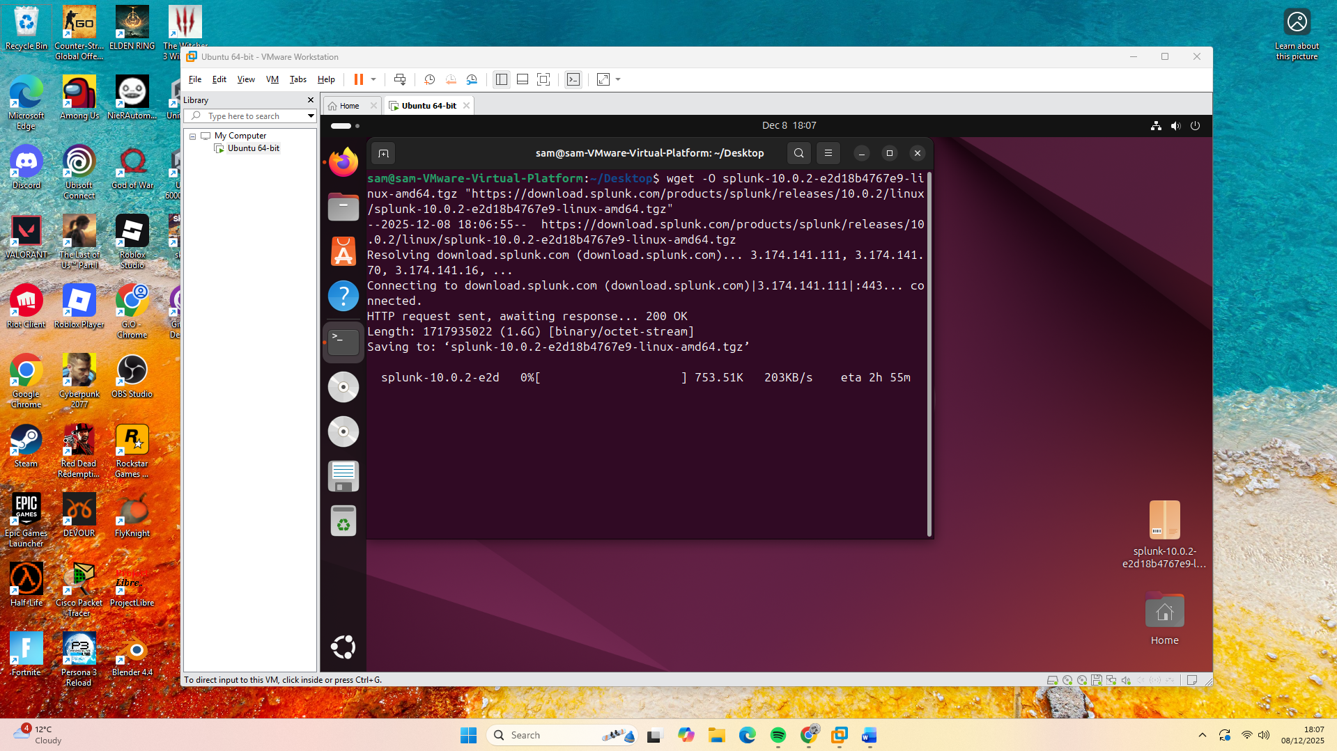

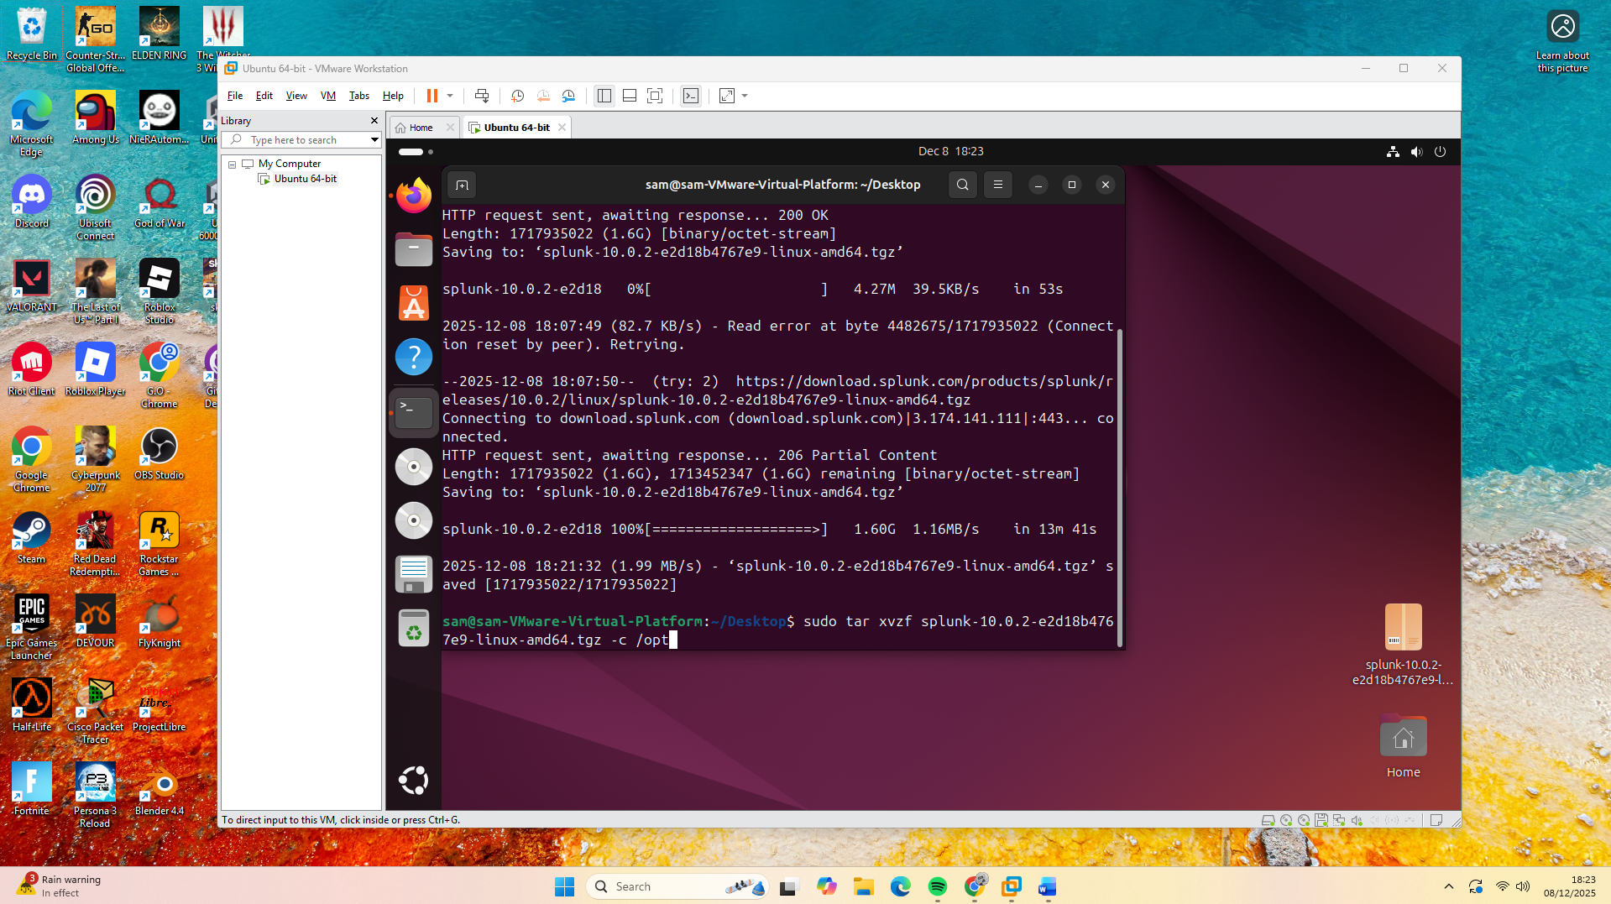

These screenshots show the instilation of splunk.

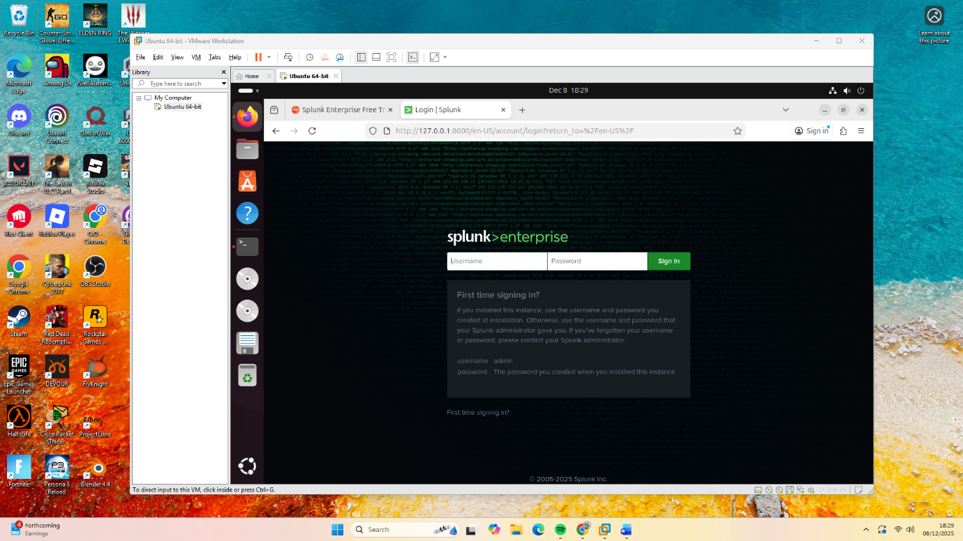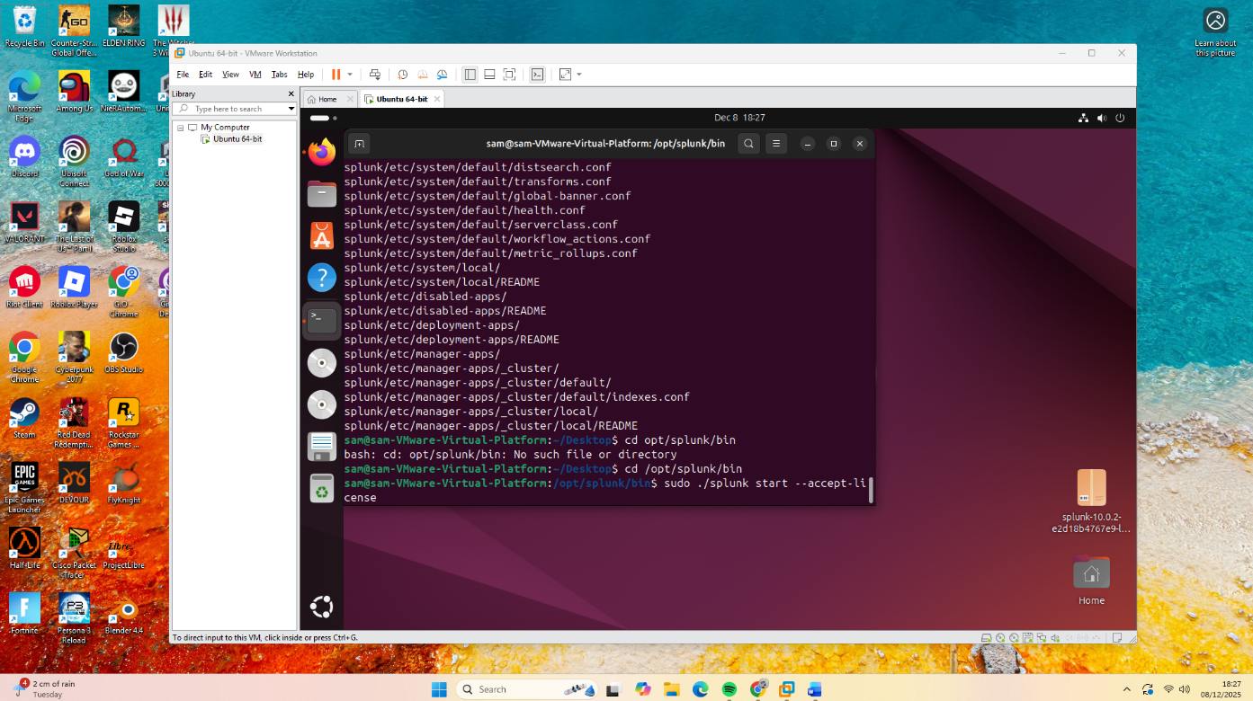This screen shot shows navigating to where the spunk folder and starting splunk

The above screenshot shows Splunk running before indexing any data.

The next step was to download the dataset from the BOTSv3 Github and the unzip it. Following that it was placed into the appropriate folder where it could then be indexed from the earliest time possible to ensure that all of the data was available for analysis. This can be seen in the bellow screen shots.

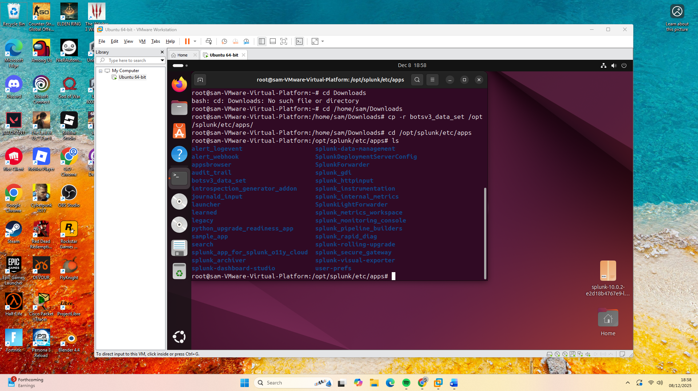

The above screenshot shows the data being copied into the appropriate folder.

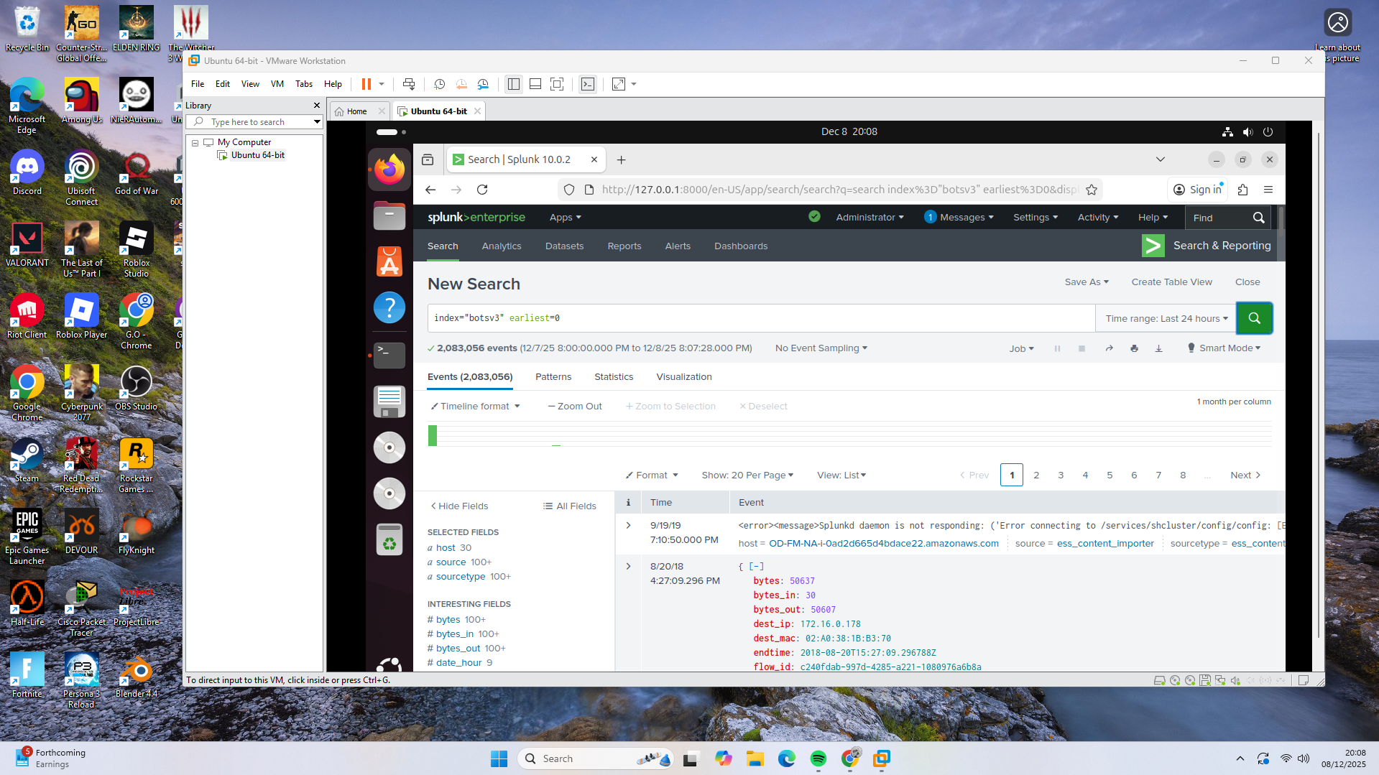

The above screenshot shows the data being indexed.

The accuracy of the data was validated by looking at the number of events captured which hits the target 2,083,056 events. This validation step is critical in a SOC context as if an analysis was being coducted on incomplete data it could lead to an innacurate analysis and missed vulnerabilities or threats to the infastructure.

# Guided Questions

# Conclusion

# References

Amazon web services, N.D.. *Blocking public access to your Amazon S3 storage.* [Online]   
Available at: https://docs.aws.amazon.com/AmazonS3/latest/userguide/access-control-block-public-access.html  
[Accessed 23 12 2025].

Bull, J., 2025. *Implementing risk-based alerting.* [Online]   
Available at: https://lantern.splunk.com/Security_Use_Cases/Threat_Investigation/Implementing_risk-based_alerting  
[Accessed 27 12 2025].

Connect Wise, N.d.. *SOC Analyst Tiers 1, 2, and 3 - what's the difference?.* [Online]   
Available at: https://www.connectwise.com/cybersecurity-center/glossary/tier-1-vs-tier-2-vs-tier-3-cybersecurity  
[Accessed 23 12 2025].

Dominguez, J., 2023. *Laying the Foundation for a Resilient Modern SOC.* [Online]   
Available at: https://www.splunk.com/en_us/blog/security/laying-the-foundation-for-a-resilient-modern-soc.html  
[Accessed 27 12 2025].

Mark Scapicchio et al, N.d.. *What is a security operations center (SOC)?.* [Online]   
Available at: https://www.ibm.com/think/topics/security-operations-center  
[Accessed 23 12 2025].

Paloalto Networkd, N.d.. *Security Operations Center (SOC) Roles and Responsibilities.* [Online]   
Available at: https://www.paloaltonetworks.co.uk/cyberpedia/soc-roles-and-responsibilities  
[Accessed 23 12 2025].

Riversafe, N.d.. *How Splunk helps organisations improve cybersecurity observability.* [Online]   
Available at: https://riversafe.co.uk/resources/how-splunk-helps-organisations-improve-cybersecurity-observability/  
[Accessed 27 12 2025].

Splunk, 2025. *Welcome to Splunk Enterprise 10.0.* [Online]   
Available at: https://help.splunk.com/en/splunk-enterprise/release-notes-and-updates/release-notes/10.0/whats-new/welcome-to-splunk-enterprise-10.0  
[Accessed 27 12 2025].